

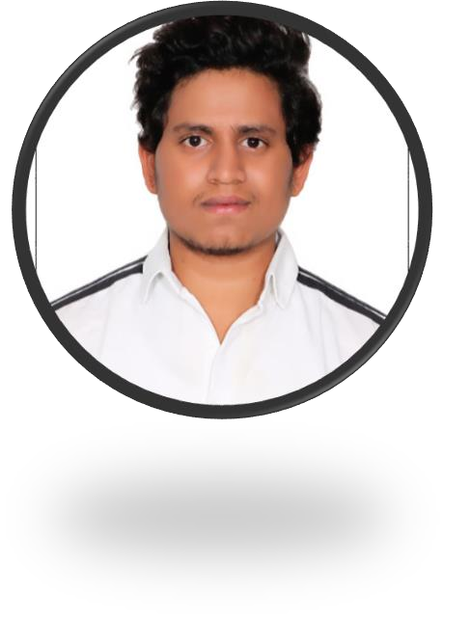 | BATTINA PRAVEEN KUMAR
Experience
- Fresher

Education
Narayana Junior College, Hyderabad, Telangana
- Completed intermediate in 2021 with 75%
ACE Engineering College, Hyderabad, Telangana
- Pursuing from 2021
- Current CGPA: 8.0

Communication
- Excellent written and verbal communication skills.
- Empathic listener and persuasive speaker.
- Writing creative or factual.
- Excellent presentation and negotiation skills.

Certifications
- The Joy of Computing using Python [NPTEL]
- Salesforce Developer Virtual Internship
- CISCO CCNAV7 Introduction to Networks Certification
- UiPath Automation Explorer for Students

Soft Skills
- Communication
- Problem solving
- Leadership
Sr nagar, Hyderabad Telangana,500038
9573668469
battinapraveenk@gmail. com



- Project management

Technical Skills
- Problem Solving through C
- Front-end Web development
- JAVA
- C++
- Data Structures
- SQL

Hobbies
- Reading Books
- Photography

Interested Domains
- Software Developer
- Data Scientist
- Web Developer
- Application Developer
- Generative AI

Projects
➔ Created portfolio website:- By using HTML, CSS, JAVASCRIPT
➔ Data Analytics Projects:-
- PROJECT TITLE:- BUSINESS SALARY PREDICTION
- Key Skills Utilized:- Python



